**Cypress Installation and Running commands.**

To run the Automation Script in Linux Machine, we need to install the below mentioned tools.

1. Install Visual Studio Code Editor
2. Install Node.js.
3. Create a folder in the local and open that folder in visual studio code editor.

1. Open terminal in Visual studio code editor and type ***npm init***

***npm install cypress --save-dev***

1. Pull Automation code from the Git repository - develop branch.

To run the Script in Cypress Open state: -

1. Open terminal in visual studio code editor

***npx cypress open***

1. It will launch cypress.

1. Click E2E Testing

1. Select any browser and click start E2E Testing.

1. It will list all the cy.js file, select anyone file eg: clin1.cy.js file.

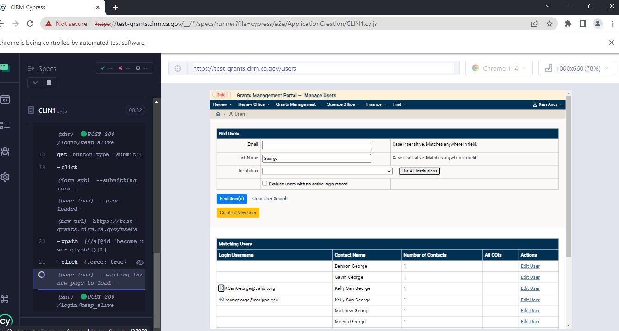

1. The script will be run, once it is completed then go to the visual studio code editor, under report we can see the report with the video.

To run the script in cypress run mode: -

1. Open terminal in visual studio code editor

***npx cypress run –headed –spec <<path of the file or folder>> –browser edge***

1. Finally, it will show the report in terminal.

